Miguel Ángel Domínguez Llorente
2025-2026
2. How to self yourself
C.I.F.P A CARBALLEIRA

Índice
No se encontraron entradas de tabla de contenido.

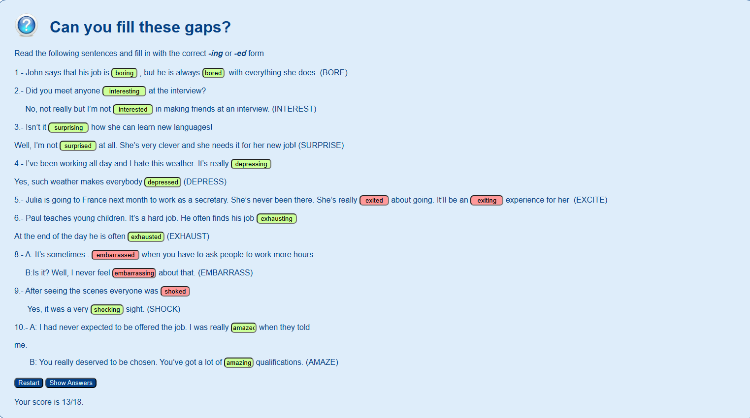
How to sell yourself
1. Use of english
Participial adjectives
theory
-ed/-ing forms
Practices [ in the pdf or web ]
Activity 1
Can you fill these gaps?
notes

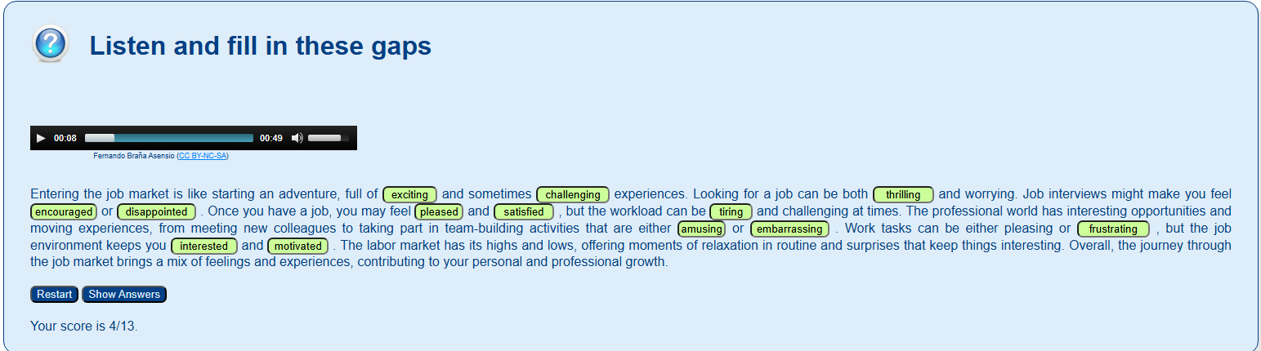
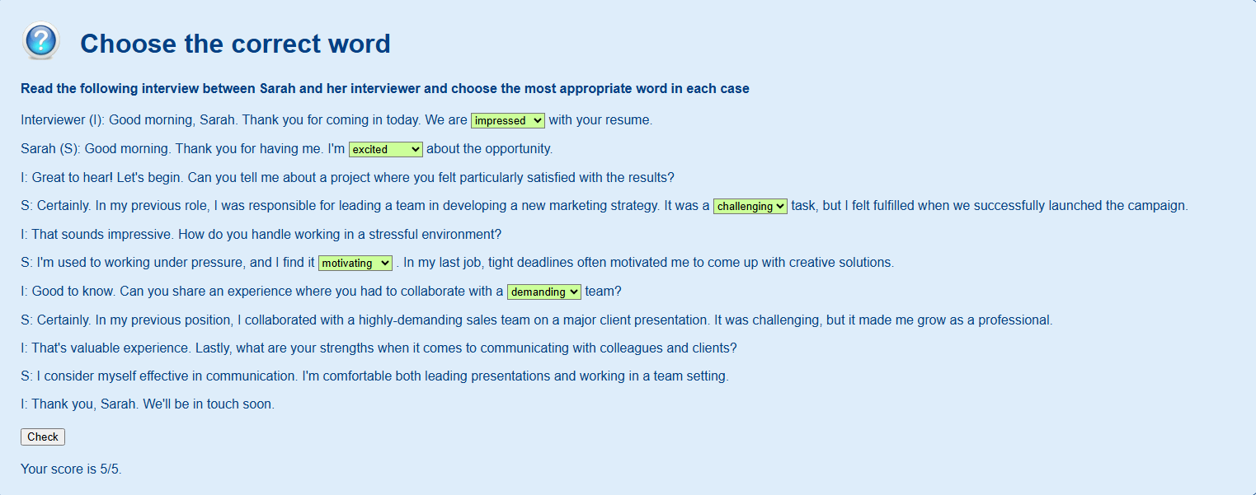
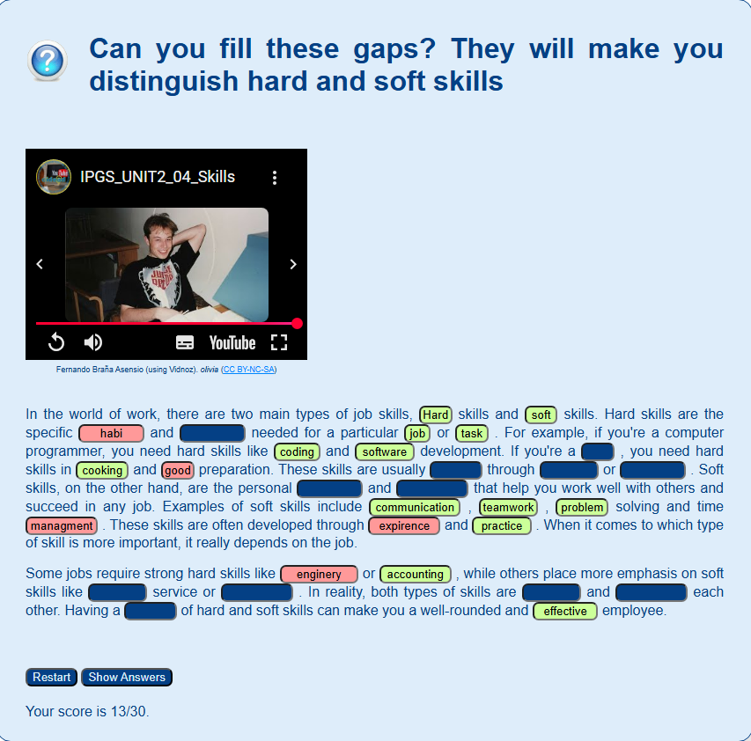
Vocabulary
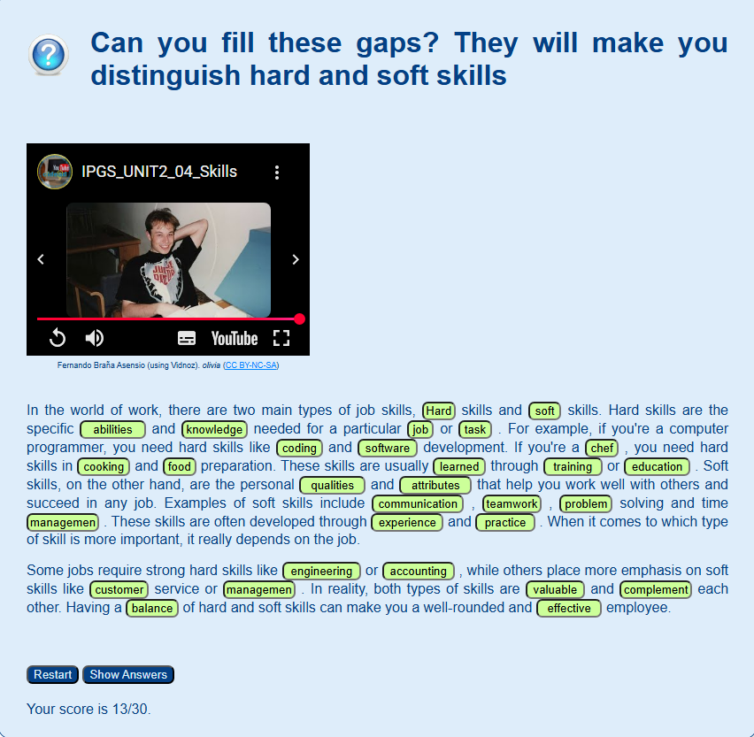
Apart 2
Listening
Reading
writing
Speaking

